1. Create an account

<https://infinityfree.net/>

1. Confirm your email
2. click on “Create an account”
3. create a subdomain for the account - MrsWeiss.epizy.com psw = CSHUNTER user = epiz_26337632! rosanew@optonline.net
4. sign in (user is generated for you)



1. to download the database, go to : <http://www.dvwa.co.uk/index.php>
2. click on download (bottom)



1. save the zipfile :DVWA-master.zip
2. go back to Infinityfree
3. click on online file manager

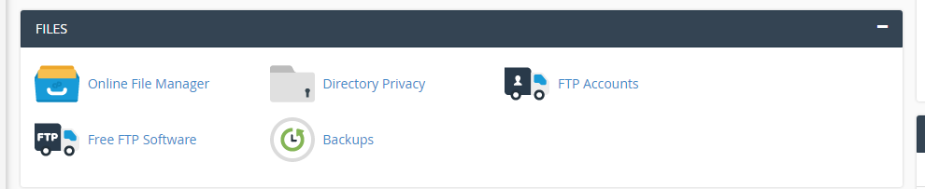

1. on bottom, click on upload to upload the zip file (by zip, by folder if you unzipped). this may take more than 10 minutes….





teacher note:

<http://34.197.52.233/DVWA-master/vulnerabilities/sqli/?id=2&Submit=Submit#>

[34.197.52.233](http://34.197.52.233/DVWA-master/vulnerabilities/sqli/?id=2&Submit=Submit#) is tsee’s class website. You should make your own DVWA and